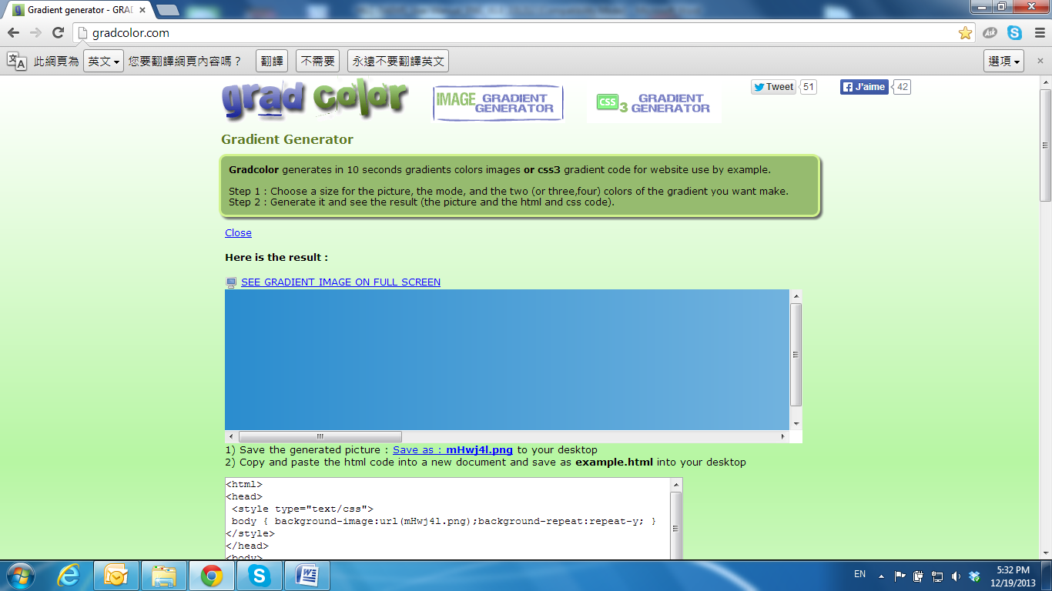

Monitor Settings

* + 1. Right-Click on the desktop. Select **Properties**

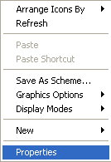

* + 1. Change color quality to highest: **32bit**.



 